Dead by daylight drinking rules – Shots Edition
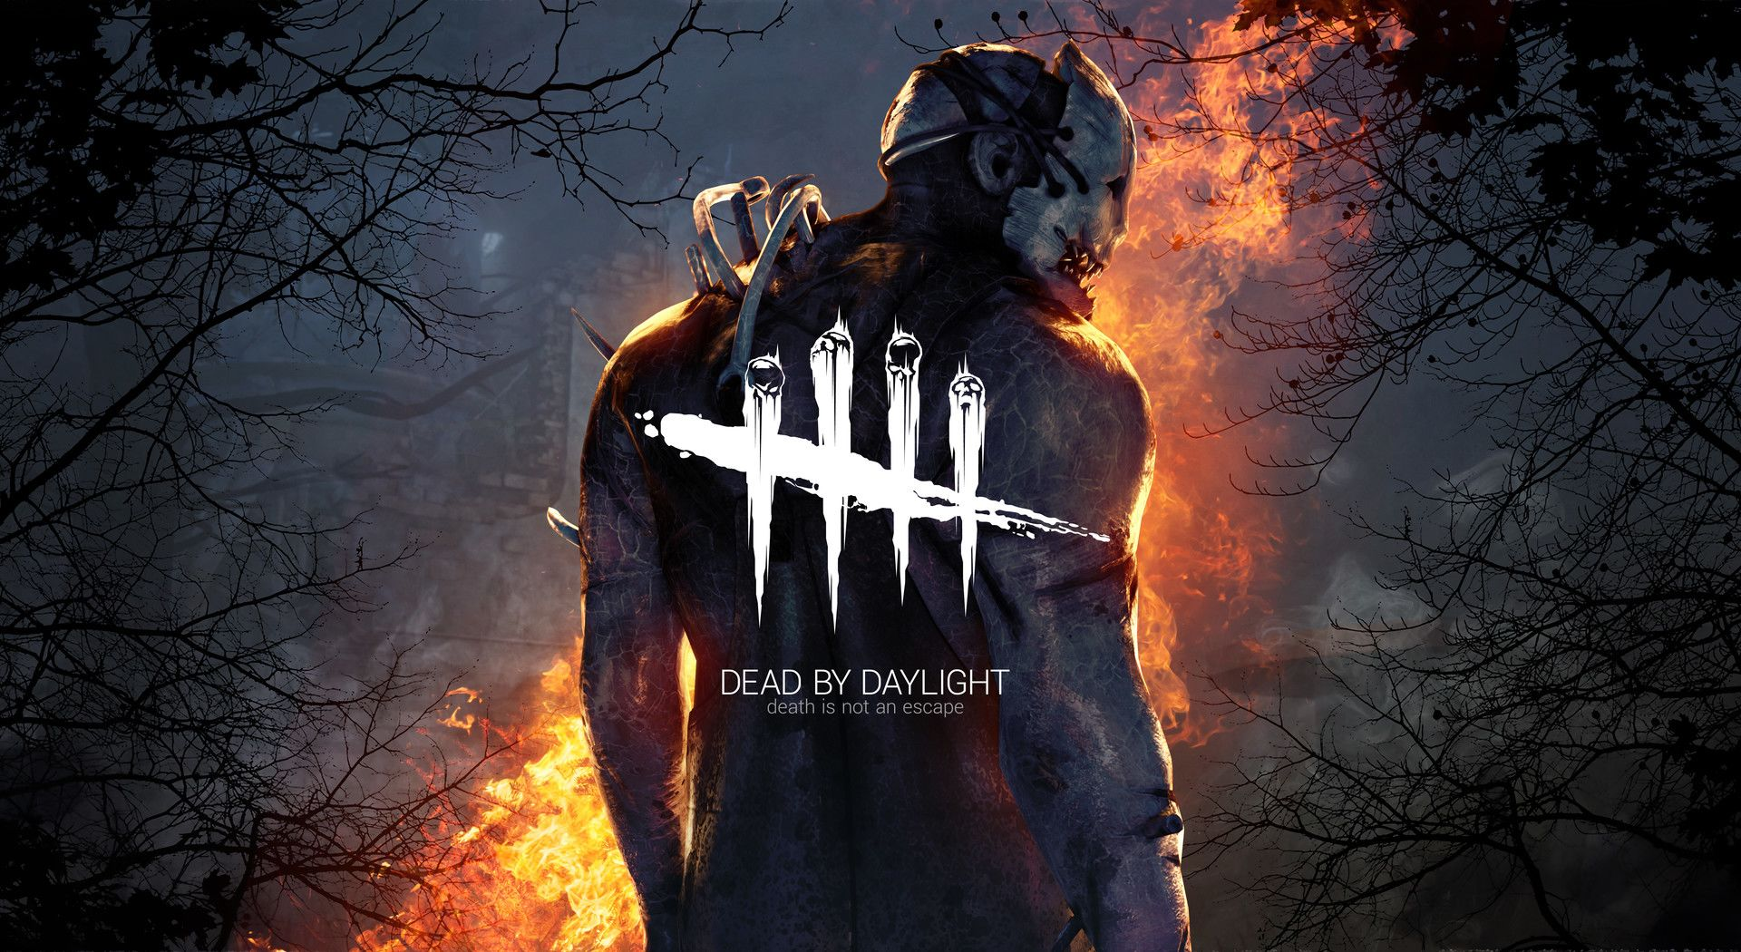

General
Whenever a rule applies, the shot must be drank before continuing the game. No new action in the game can be taken without drinking your debt. This also counts for specific killer rules. Please see the “3 shots rules” for the punishment of not respecting it.
Scenario 1: You are hiding from the killer and decide to run to a generator. Just when you start running you notice the killer is “The Doctor” you are now in debt and have to drink 0.5 shot.
You can remain “running away” because you were already running, while running away you can take the shot and clear your debt. If “The Doctor” would hit you, you do not have to take an extra shot.
Scenario 2: You are hiding from the killer by crouching in a field, you notice the killer is Freddy (but were still crouched) you are now in debt and have to drink 0.5 shot.
You CANNOT run away because this would be a new action, so you have to stay crouched until you finished your shot! Freddy finds you and hits you before you could finish your shot You are now in debt 1.5 shots
You still can’t run away and have to stay crouched! You have to finish your debt! Freddy hits you again and you go down. you are only in debt for 1.5 shots, the rule does not apply again.
Freddy carries you to a hook and you have enough time to finish your shots.
Be aware, if you do not finish your debt before you have to struggle, you cannot struggle! This will cause you to die and come in debt of 2.5 shots!

0.5 – shot rules
Whenever a survivor is saved, that was not saved by you, drink 0.5 shots.
- (2 player variant : When a survivor is not saved by one of you, drink 0.5 shots)
If you go down with full health, while being “exposed” and die, take 0.5 extra shot on top of the die shot.
Whenever you die, drink 0.5 shot.

1 – Shot Rules
Whenever you are found in a locker, drink 1 shot.
Whenever the killer hits you before you have drank your debt, take 1 extra full shot.
Whenever you die in the basement, drink 1 extra full shot.

2 – shot rules
Whenever you call out a killer, and it is the wrong killer, the player who did the call out needs to drink 2 full shots.
Note: you can still “think” it is a certain killer.

3 – shot rules
If you are in debt, and do a “new action”, drink 3 full shots. This rule must not be broken and must be respected!
Note: For instance, the exit gates are opened and you get hooked, all your teammates escape except for “1 random player”, the random player saves you from the hook You need to drink 0.5 shots
You cannot run! This is a new action! Finish the 0.5 shots! BUT: you notice the killer is close, and you will not make it if you need to take the shot first, you sprint for exit gates and escape.
- You broke the new action rule, but still won, you now have a debt of 3.5 shots.
Note 2: keep extra shots ready on the side, in case you know you will have to drink, keep them ready! The faster you take you debt shots, the faster you can start running!
If everyone in the group died, while the killer had no perks on, take 3 full shots. You are a disgrace for this game…

Killer specific rules – aka you are fucked

Trapper
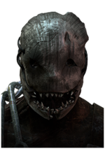
If you run into a trap and you tried to unhook a survivor, you must drink 1 full shot.
If you are stuck in a trap, and cannot escape from it and the killer grabs you, drink 0.5 shot.

The nurse
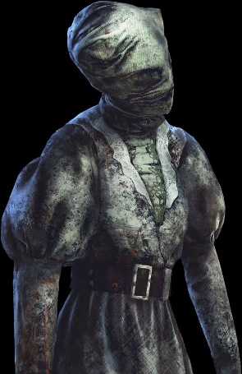
If the nurse blinks through an obstacle and hits you, drink 0.5 shots.

The hillbilly
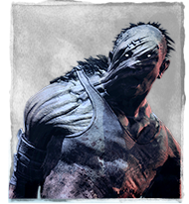
If the Hillbilly revs up the chainsaw when he is further away than 40 meters and hits you, you need to drink 0.5 shots.

The hag
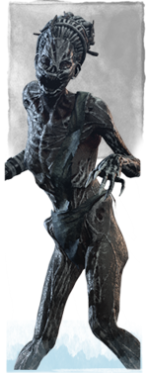
If the hag teleports to one of her clones, and hits you, drink 0.5 shots.
If you are the only one left, and no one else escaped, using the trap door for your escape gives you the power to let everyone else drink 1 full shot shot for your awesomness!

The Clown
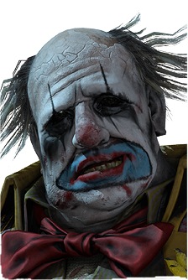
If you are hit by a bottle of the clown, while not being in its terror radius, drink 1 full shot.

The Doctor
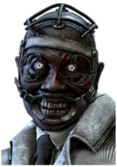
If you play against the doctor, drink 0.5 shots.

Freddy Krueger
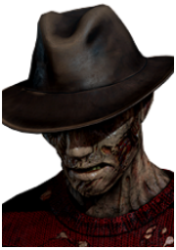
If you play against Freddy, drink 0.5 shots.

The Huntress
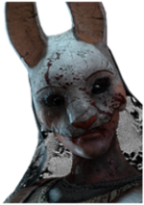
If you drop a pallet, and still get hit by a throwing axe, drink 1 full shot.

The Pig
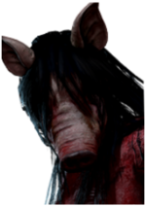
If you get a helmet on, take 0.5 shots.
If you die by the effect of the helmet, take 1 extra full shot on top of the die shot.
If you escape while having a helmet on, everyone else takes 2 shots.

The Spirit
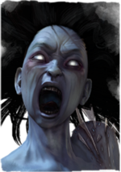
If you clear the “spirit” totem causing everyone to go in a status of “Exposed” drink 2 full shots.
Note: this only counts for this killer, on other killers this does not count.

