This is an archive document of EVERY TIME I’ve ever killed Dwight, the LAMEST SURVIVOR in the ENTIRETY of Dead By Daylight, which is stated NOT JUST in the game’s canon, but is ALSO used to describe the people that play as Dwight.
Few Dwights have escaped me and gotten to leave the match unharmed, some have taunted, some have spammed the Flashlight AND the Pallets, and as a result, I hate every Dwight player that exists.
In fact, I’ve even clipped some of my Dwight kills on my Xbox profile, so any Dwight kills that AREN’T on here either WILL be if I find them on the official Dead By Daylight Statistics Tracker, OR, I will have recorded them on Xbox.
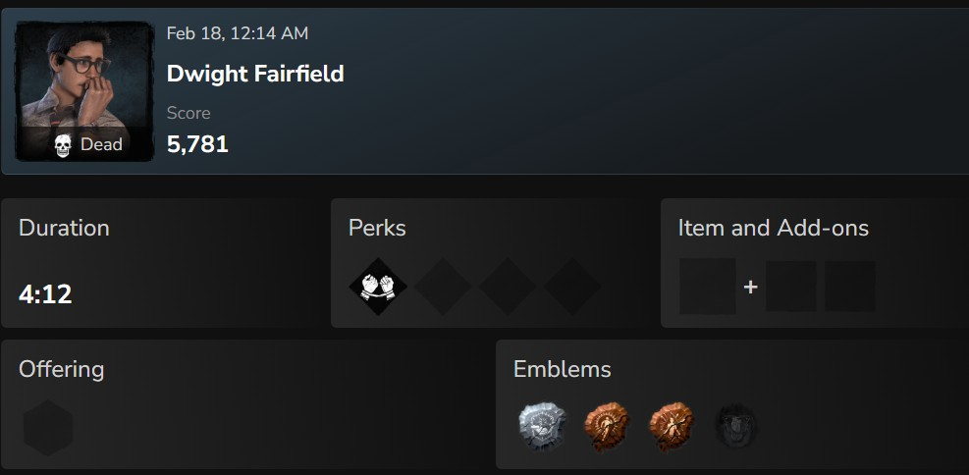Wednesday, February 18, 2025, 12:14AM.
I don’t even remember what all he did throughout the match, because as you can see just from his loadout, he did fuck-all of ANYTHING during it.
As you can tell, the possibility of encountering another Dwight to kill makes Dead By Daylight’s Killer matches more fun for me, the thought of destroying the Survivor that I hate the most, MOTIVATES me to win, so SOMETIMES I get a bit “tryhard-ish”, and I end up either getting to kill him with my equipped Memento-Mori, OR he dies at the end of the Second Hook Phase, but both are acceptable in my eyes.
THAT is WHY I AM the Dwightslayer, a unique nickname for an EQUALLY unique reputation amongst the Killers of Dead By Daylight.
I WOULD have gone with “Dwight-Knight”, given that my Knight is Prestige 15, but that name just seemed too obvious, after all, Knight IS my highest-Prestiged Killer, but I tend to have fun with OTHER Killers too, such as the Lich, AKA Vecna from Dungeons & Dragons.
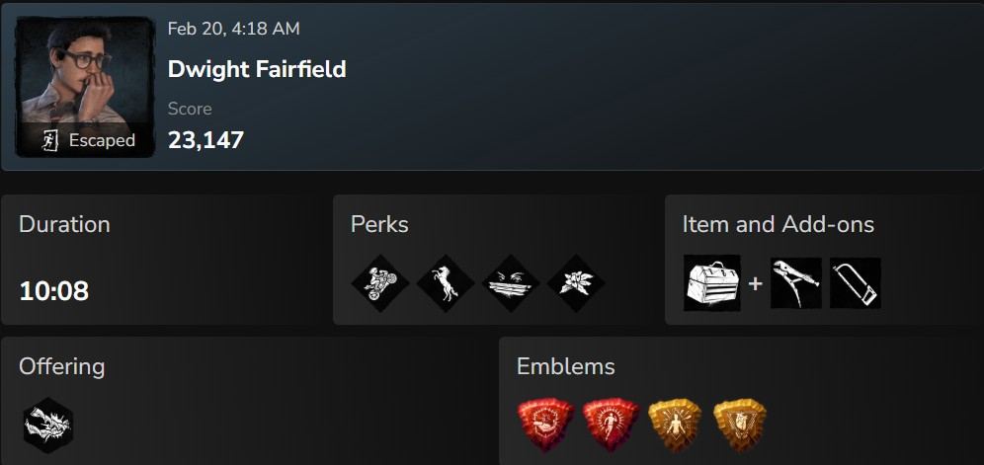Friday, February 20th, 2025, 4:18AM.
THIS Dwight is an exception because HE was a TOXIC LITTLE BASTARD, constantly taunting me, spamming his Flashlight for no goddamn reason, AND dropping Pallets on me until he got through the Exit Gate.
He only realized the Pallets were his last resort when his Flashlight finally ran outta battery power, and unfortunately for me, Pallet after Pallet after PALLET, he escaped, after I’d already downed him 3 times AND put him on a Sacrificial Hook TWICE, before which, he was already being healed by a teammate and fellow Survivor.
As you can see, when a Dwight starts getting annoying, it motivates me even FURTHER to finish them off and end the match for them, its more rewarding when they know they’ve come SO FAR, and yet it’s been all for naught, because in the end, the Dwightslayer almost ALWAYS takes his trophy.
I take MY trophy.
In all seriousness, this is just a list of how many times I’ve caught and killed this fuckin loser of a Survivor, ESPECIALLY since even the Chapter trailers depict him that way.
Any time Dwight is being chased by a Killer in a trailer for a new Dead By Daylight chapter, he’s always stumbling, getting injured, and almost ALWAYS getting caught in the end.
So, I’M playing it UP on that tradition, and prioritizing the bait-n-tackle of the game.
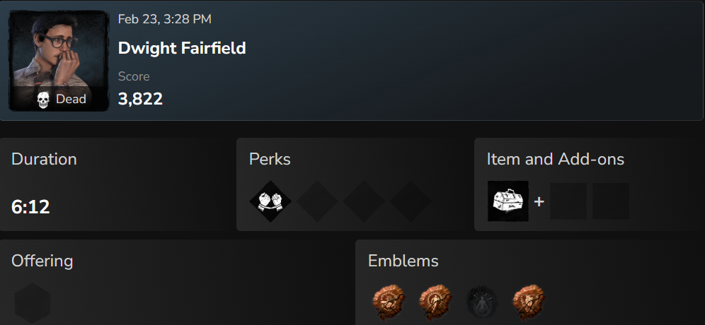
Monday, February 23rd, 3:29PM
This one was today, a new bounty, and a new prize, he barely put up a fight.
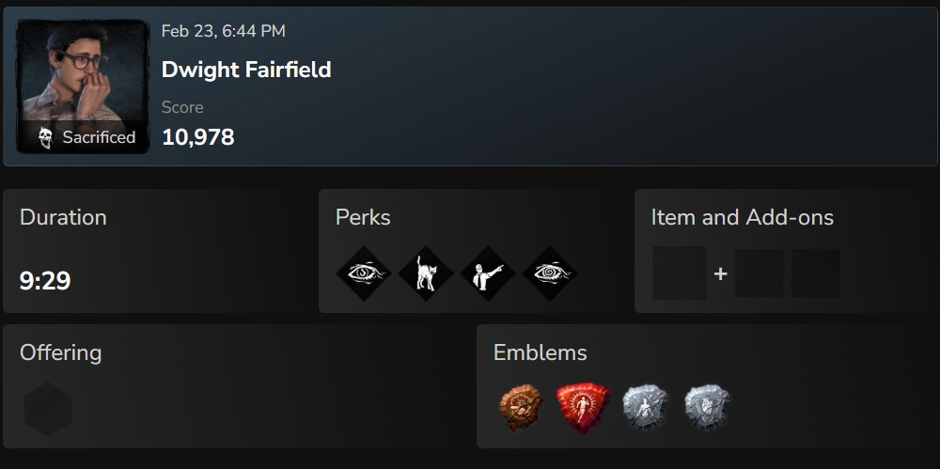
Monday, February 23, 2026, 6PM.
This kill wasn’t mine, the Dwight in question ACTUALLY belonged to the Killer that he, I, and 2 other Survivors were playing against as a team.
I’ve been having a hard time finding Dwights to kill lately, having only gotten 1, and then, I end up finding THIS bastard ON MY TEAM, the ONE CHARACTER I ENJOY GETTING RID OF, and it’s THIS motherfucker, and as a result, it ruined my ENTIRE MOOD, RIGHT on top of the fact that he FAILED A FUCKING GENERATOR Skill Check, which IMMEDIATELY ALERTED the Killer.
So I put him in here just as a piss take, since he pissed me off unwittingly.
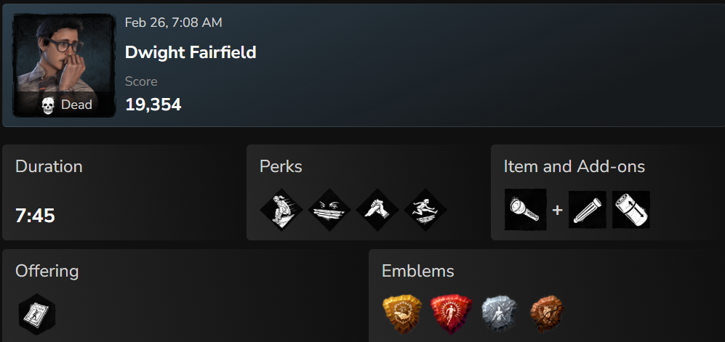
Thursday, February 26th, 6:28AM.
This Dwight spammed his Flashlight until it ran outta battery power, yet he struggled SO HARD against ME, the Dwightslayer, but to NO AVAIL, being the 5th Dwight in JUST this Archive ALONE, AND a pretty good kill to end off the night.

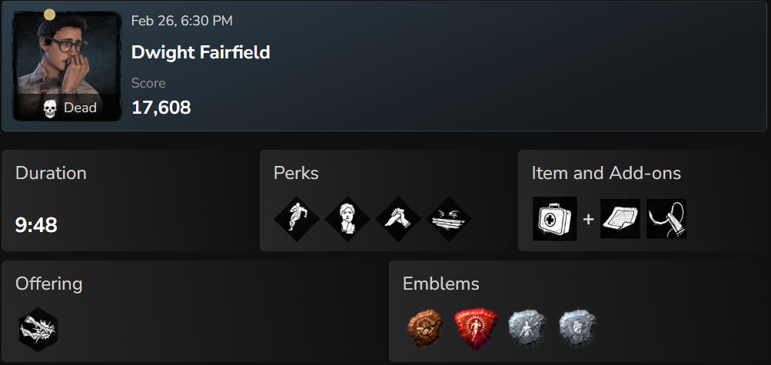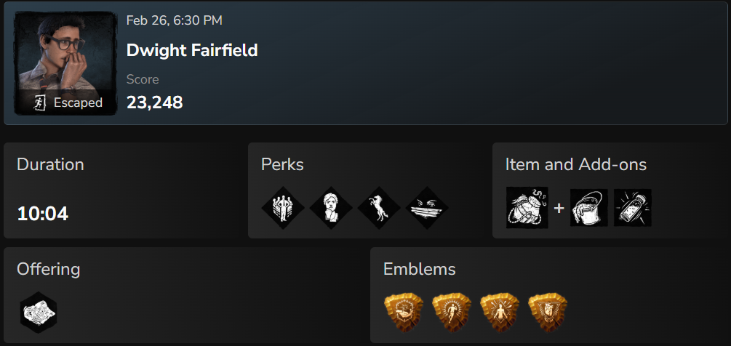
Thursday, February 26th, 2026, 6:30PM.
These two teammates I will call Harold (Left) and Kumar (Right), Harold dropped a few Pallets AND he taunted me, so he died first, whereas Kumar did fuck-all of ANYTHING, and despite being put on a Sacrificial Hook TWICE, Kumar eventually AND unfortunately escaped.
Harold and Kumar are now the 6th and 7th (DON’T YOU DARE LAUGH) Dwights in the Dwightslayer’s Archive.
MY Archive.

Tuesday, May 16th, 2026, 12:03AM.
I killed THIS Dwight using my newly-equipped Attack Titan skin for the Trapper, which turns him into an ENTIRELY different character, changes his menu music and all, but keeps his Memento Mori the same, and BECAUSE the Attack Titan is one of my four favorite Titans in Attack On Titan (the others being Grico’s Jaw Titan, Reiner’s Armored Titan and Annie’s Female Titan), I am now a Trapper semi-main, meaning I play Trapper every now and then just for the sake of using the three Attack Titan skins.
Friday, May 26th, 2026, 3:19PM
I entirely forgot that I killed this one, and I did it using Vecna from Dungeons and Dragons.
Sunday, May 28th, 2026, 3:35PM
THIS one I killed using Deathslinger, who’s VERY fun to play once you get the hang of his harpoon gun, which is even more fun to use when it’s against Dwight.
Sunday, May 28th, 2026, 3:35PM
Killed this one with Deathslinger too.
Thursday, June 4th, 2026, 6:50AM
Friday, June 5th, 2026, 4:51PM
This one was on the same team as the previous one, and I killed both of them, but I don’t remember which Killer I used to do it.
Sunday, June 21st, 2026, 8:17PM
This one didn’t do all that well against my Deathslinger.
Thursday, June 25th, 2026, 2:12AM
THIS one is a freshy, I just got him today.
Thursday, June 25th, 2:12AM
Ths one and that other one were on the same team.

