Author: Mora Vang and my brother Kongmeng Vang (Helped me with the killer and perks.)
Calling of the Shaman Chapter
A damned elderly person is sick in the Hmong village (a modern community in the US) and a Hmong shaman is called to help a Hmong family. The shaman comes to perform a ritual to find out that a tiger spirit has taken the spirit of the person for marriage. The shaman and her spirit guides are to fight this evil spirit to bring back the damned person’s spirit. During the ritual, there are many dimensions open to travel from and to. This lets it easier to access the realm of the entity to which the shaman and fury slip into. With her knowledge of spirituality and skills in saving the damned she works up the will to help survivors escape with her guidance. For the Fury, he does not allow anyone to take the crown off of his head as he is the King of the Jungle. He decides to work with the entity to get his revenge on the shaman who took his love from him.
Shaman Perks:
Call of the Spirits – A protection perk, within 16 meters of an injured survivor you can send a spirit guide to protect them and instead of being in the dying state they will suffer the endurance effect instead and gain 150% haste for 3 seconds. The person who runs this perk will suffer the exhaustive effect for 60/50/40 seconds.
Flute’s Journey – An activation perk that allows you to interact with a hook. When a survivor that is not you is hooked you can interact with a hook that can summon that survivor to that hook if killer is face or proximity camping that survivor. This earns you a token up to a maximum of two tokens for the duration of the match. When you are hooked, you can use the activation button to consume a token. You will be transported to the furthest hook from the hook you were on. In the struggling phase, you can consume another token to transport yourself to a hook closest to an exit gate. If the killer is within 8 meters when using the tokens, they will be stunned for 5 seconds.
Boon: Guidance– A boon perk that allows bells to call forth the spirits to protect survivors and confuse killers. Once Killer gets into the radius of the boon, they will hear a slight jingle of the bells. Killer will suffer auditory noises and visual distractions. Such as generators popping, pallets dropping even if there are no pallets nearby, vaulting of the windows, opening of lockers, etc. Once Killer steps out of the boon radius they will see scratch marks in every direction for 3 seconds.
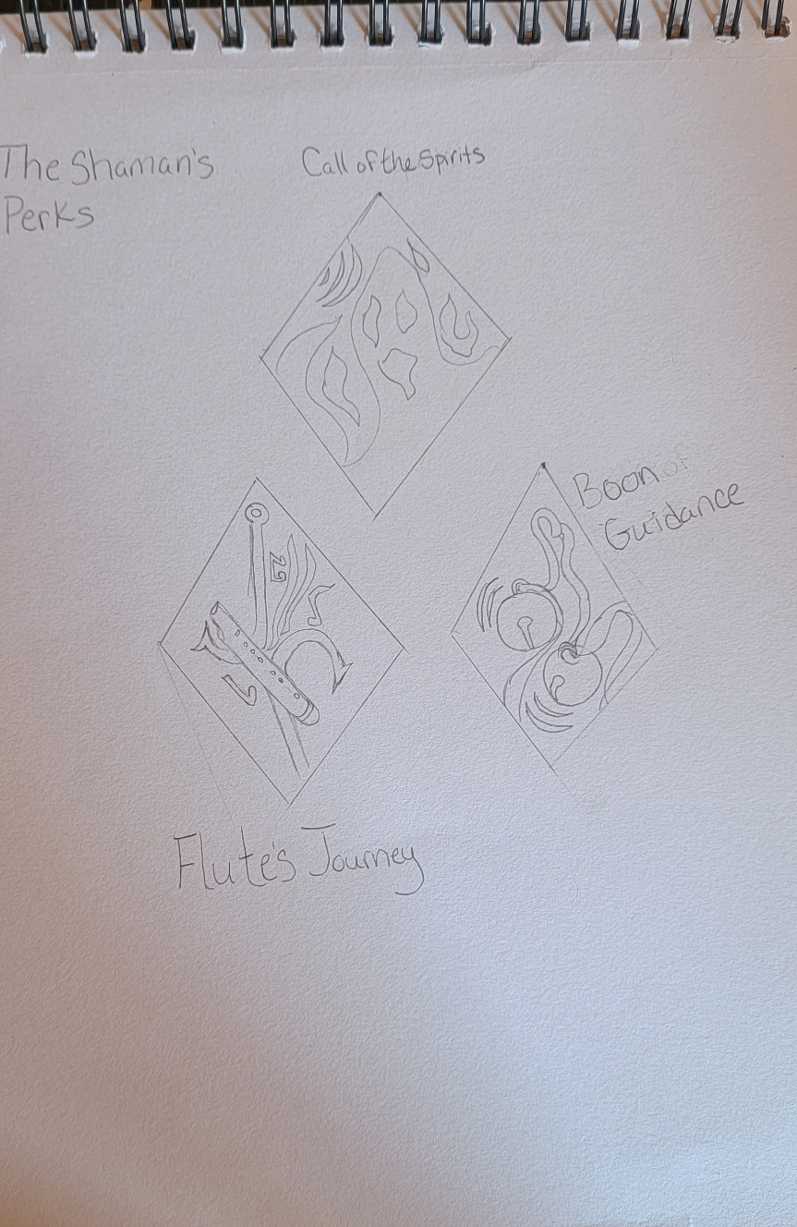
The Fury:
Special Attack: Roar of the Tiger – Allows the Fury to charge a roar to scare survivors up to 8 meters and a cone of 8 meters to fill up a survivor’s Fear Meter. The Roar will also disorient the survivors so that they cannot vault or drop Pallets. A fully charged roar will add one bar of Fear. Hiding in lockers are also useless but will result in half of a bar of Fear instead of one. Once the Fear Meter is full, Survivors are exposed and cannot see or hear The Fury. Every 15 seconds you’ll see the aura of The Fury for 5 seconds if a Survivor is Terrified. Survivors can reduce Fear by interacting with other survivors to reassure themselves. Survivors with Four bars of Fear will see hallucinations of other moving survivors and moving Killer. Interacting with hallucination Survivors will build the Fear Meter and that Survivor will scream, revealing their location. Interacting with a hallucination Killer, it will attack and result in the loss of one health state. Hallucination Killer has no Terror Radius and will roam like a normal Killer. They have collision so Killer can use this to their advantage.
- Little Minions – The Fury has two small hags that roam the map and scare survivors for half a bar of Fear. They can phase through objects and have no collision. Interacting with them will result in a Survivor screaming and revealing their location. During end game they will start gliding with a brand full of leaves over their heads towards survivors.
- The Beast – When the Fury has enough Fear built up, he can transform into a Tiger. Moving at 7.6 m/s, Survivors are exposed, Pallets and Doors will be instantly broken upon contact and have no slow down as well, cannot be stunned by any means, vault speed is a 100% faster, and can mori a survivor in Beast state if they down at least two other survivors. This only lasts up to 15 seconds, but the timer will reset if successfully downing survivors. In Beast Form, the Killer Instinct is constantly active.
- Burn Incense Sticks at the Shrine – Sometimes survivors will need more than survivors for reassurances which leads to burning incense sticks at the shaman’s shrine to help guide your spirit back to you (3-5 seconds to burn). Once the ritual is done you will hear the sounds of the gong which will notify the Killer where you are. He wouldn’t like it if your spirit returned back to your body.
  - How Shaman Shrine and incense sticks is to look like –
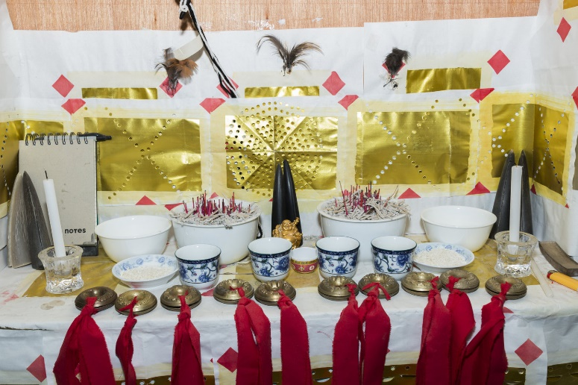
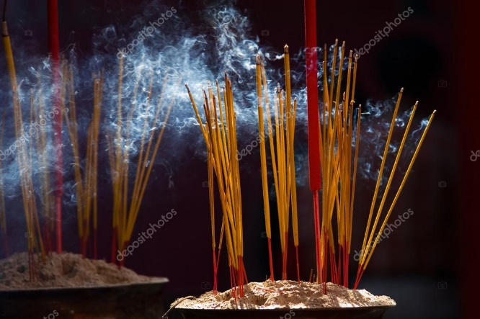
Injured Prey – If Killer hits a survivor, Chasing Prey activates, hindering 50% speed for that survivor for 10 seconds. Cool down for 35/30/25 seconds.
Giggle – Once you pick up a survivor you can trigger the little minion’s giggle. This makes you see all auras of other survivors for 8 seconds and when hooking survivor, you are hidden by the veils of darkness. (undetected status for 6/8/10 seconds)
Hex: Tiger’s Fury – When a Killer gets a hit with their special abilities on a survivor, the hex totem is activated, and they gain a maximum of 2/3/4 tokens. When coming into contact with a dropped pallet or door, instantly break said dropped pallet or door and suffer no slow down but will still lose bloodlust if in a chase. If the Hex is cleansed, you keep any remaining tokens.
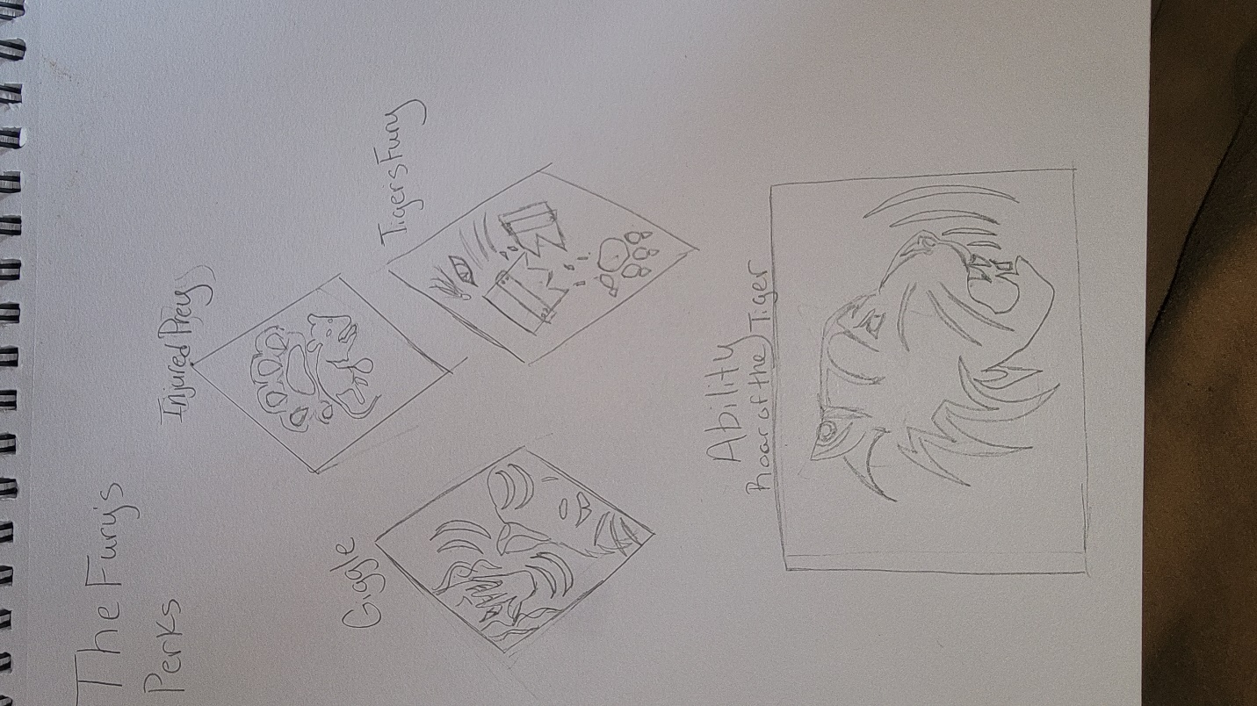
Shaman’s Story – Born at the brink of death, Kimora Vang came back from what would have been impossible. She would be given hlu plig (calling of the spirit) ceremony to make sure that her spirit was intact. If not, her spirit would continue to roam but she grew up normal live with special needs. After her return to life, she came back with gifts that granted her to see, hear, and speak to the dead. By the age of six her grandmother from her mom’s side came to her in a dream to tell her that she will be gone on a trip and will not know when she will return. Upon waking up, a neighbor from her grandmother’s house next-door came to bring news that her grandmother had passed to her mom. With this news she told her parents of her dream, and her father would take her to a shaman to see if she was telling the truth. The Shaman would reveal that what she had said was in fact true. The Shaman asked her parents if she could take her under her wing. Her parents were hesitant, but they agreed to let the Shaman take their daughter to train in the ways of the Hmong Shaman.
As one of the youngest Shamans only at 21, she would fight spirits of evil who tormented families to demonic forces to saving the lives of the damned and to curing the ill of spiritual sickness. With her knowledge she would be called to save a damned elderly woman who was tormented by an ex-lover who had died and became a tiger. The elderly woman’s husband tells her that his wife has been asleep for almost a week and their family is worried. With her abilities to go into a trance to enter the spirit realm in spirit form where she would be surrounded by her spirit guides. They tell her that she is to only see what was going on, but yet instead found herself ready to go into battle with the Fury. A tiger spirit who wanted to be with his lover since the time before the Vietnam War was not going to back down. He too had a little army willing to fight for him and before she could bring her sword down on him a portal would open. Spider like claws would pull them into the Entity’s Realm. Upon arriving as spirit form who can be hurt by this force, she knew that something bad would come and she knew that people would need her guidance. She would take form as a survivor to help others escape their doom.

The Fury’s Story – A young man born into a family curse has fallen in love with a beautiful woman well known in his village. He approached her with a flower and upon his surprise she took the flower with a smile. This was their story of love at first sight, but it would all end in tragedy as her parents did not approve of him. Yet they decided to drink each other’s blood as if one dies the other will come get them so that they can be forever together. As a three days pass, her family and her would leave the village suddenly and his heart would become an empty broken shell. He would become sick and die of a broken heart before the Vietnam War had begun. His family would soon bury him without a proper ritual and soon darkness would be fall his village within days. Cows, goats, pigs and chickens would go missing. Dogs and cats would be mutilated. People who were healthy would end up dying without a cause and some people would spot a creature late at night sneaking into pig pens. The squeals of the pigs would ring throughout the night and families would keep their doors shut tightly with ropes and bamboos. With night horrors the villagers blamed his family for the curse, the curses of turning into a creature after death with fury and revenge. Slowly, would the villagers move out of town as due to war and the Fury. The village soon would become an abandoned village in the jungles.

With more than enough strength and power the Fury would travel between the physical and spiritual realms to find his love as she was no longer in Laos. When he found her, she was by herself at the garden house waiting for her parents. She was young and youthful as he remembered her. The Fury would look to his little hags and motion for one of them to do something. With a branch full of leaves the hag would wave it around him and he starts to look like how he use to before he would approach her. This gave the Fury a little more time to keep her in this world of dreams. There they would hug each other like how they use to when they were together. He promised that he would take her with him and that she will become his wife. She would smile beautifully and nod her head. She was content and happy as tells him that she would be ready to go with him when she can stop hearing the cries (she is still conscious as she is in a comma like state in the physical realm of the living so she can hear her family crying and calling for her on her death bed) . With that he would agree and keep her company in the jungles of their old home. As what seemed like forever would soon disperse as there would be bells jingling around them. This would confuse his lover and soon she would turn into a transparent spirit. As if being pulled and picked up from behind she would return to her elderly state and go back the realm of the living to her sleeping vessel. The Fury would become angry as he knew the savior came to take his bride. The shaman with the red bandana would make her presence known and ask of him nicely to let the elderly woman go as he is a spirit and she is of the living. That spirits and the living cannot be together and she will have to fight him if he is to persist. Knowing that the shaman was only here to check up on what was going on. The Fury would not take his chances with her and lunge at the shaman. This would cause them their battle but then something would interrupt their feud. Claws of spiders would grab them and pull them into a realm of the unknown. This made the Fury more ferocious and willing to fight back but the entity offers him a chance to kill the shaman for his revenge. That he will be promised his bride. This led him to work alongside the entity with no trouble at all.
Map Ideas –
Running up and down hills. Going through the abandoned village in the jungle but with modern day houses.
Abandoned Village in Jungle concept

Main Building – but bigger and more spacious as well as broken down
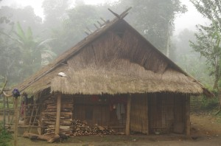
Inside Main Building and for other buildings – same with the shack
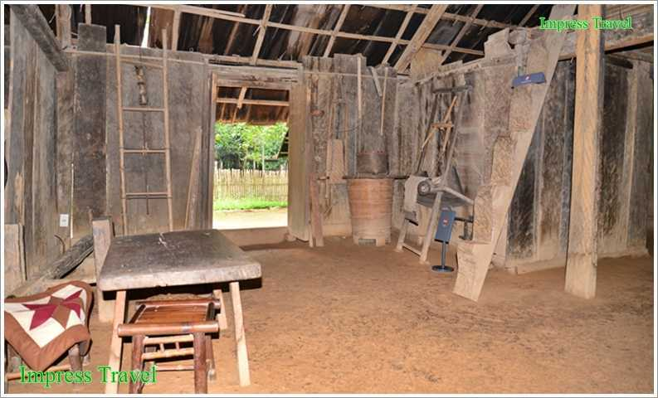
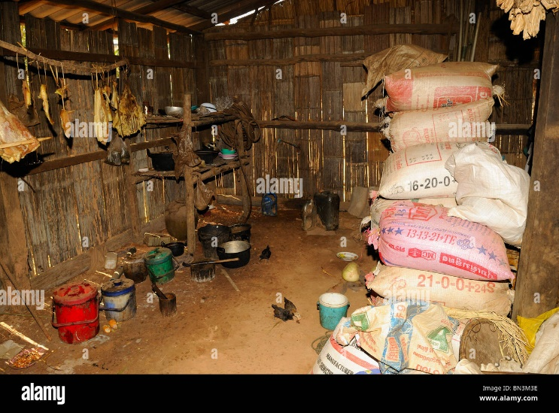
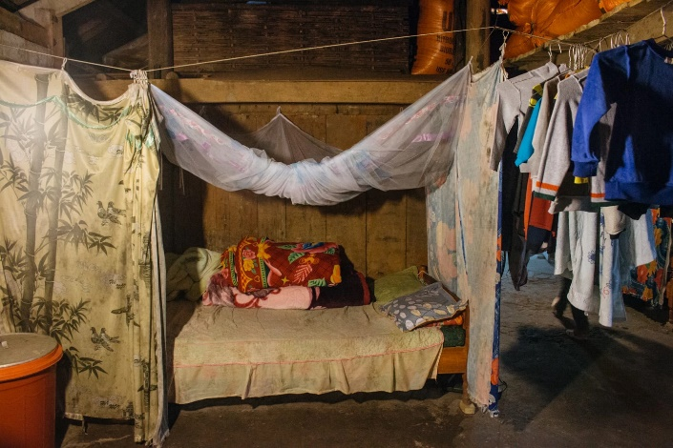
Killer Shack – it is a garden house where people rest and take naps but expanded to look like a shack but where you can enter from the open space than a closed-up building
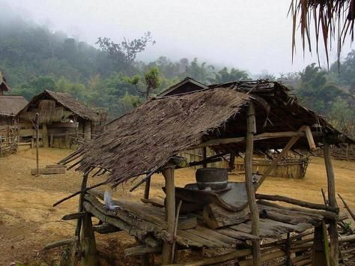
The Fury clothing –
Presentation to Meet You – His face is supposed to be a little scarier and his skin complexion is paler and grayish. He also has amber golden eyes that are similar to a tiger’s. Has claws that are used as his weapons and he is also barefooted with claws.
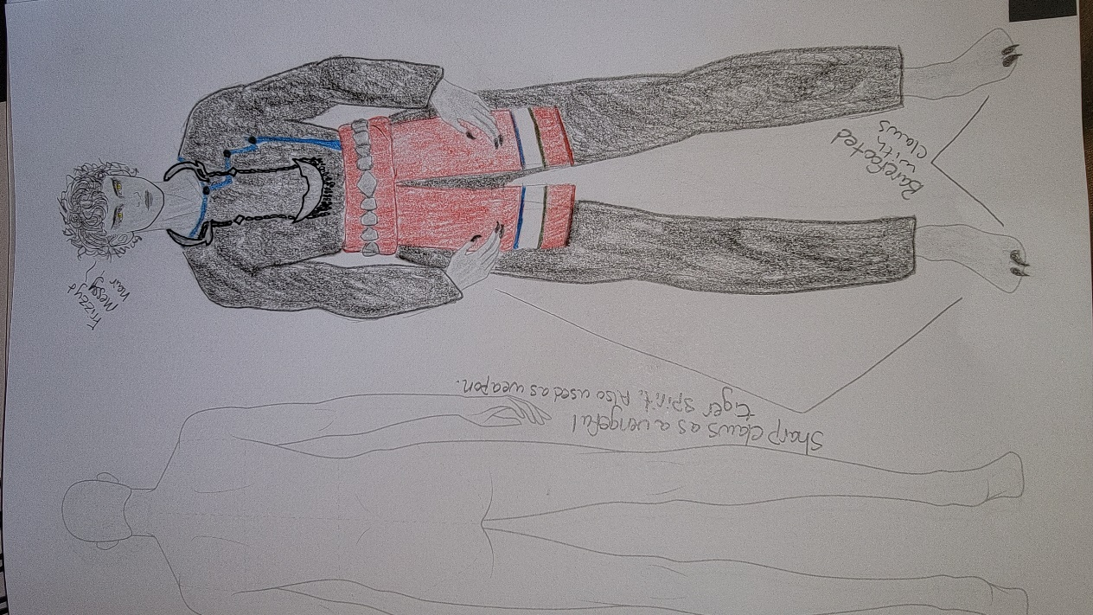
Villager Boy – When he was still alive and thriving. Uses a Hmong sickle in place of his claws.
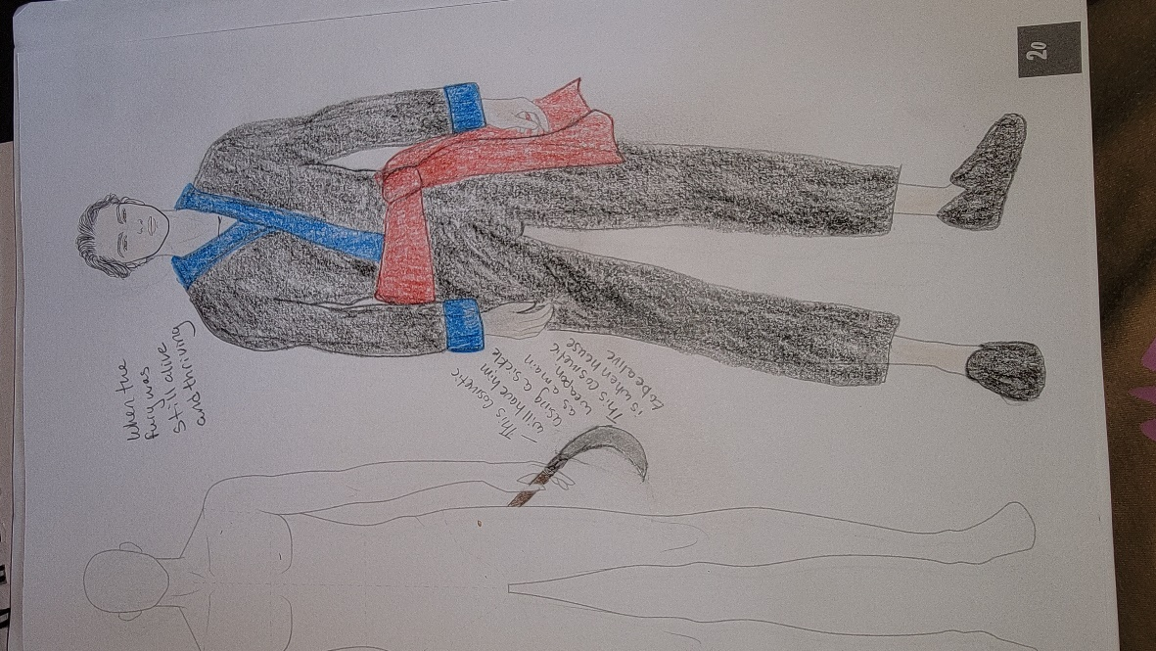

Legendary Outfits –
Husband Tiger –
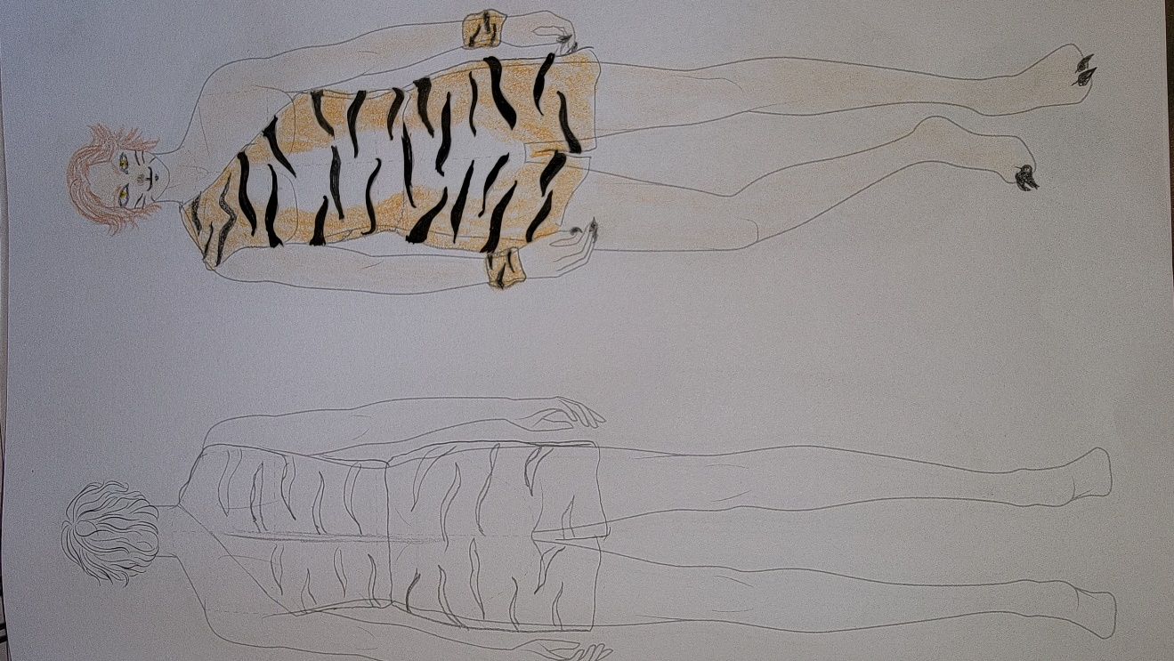
Modeled after this folklore movie’s Tiger Husband
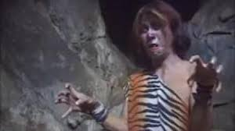
Shaman’s Clothing Adaptation –
Survivor’s Head –
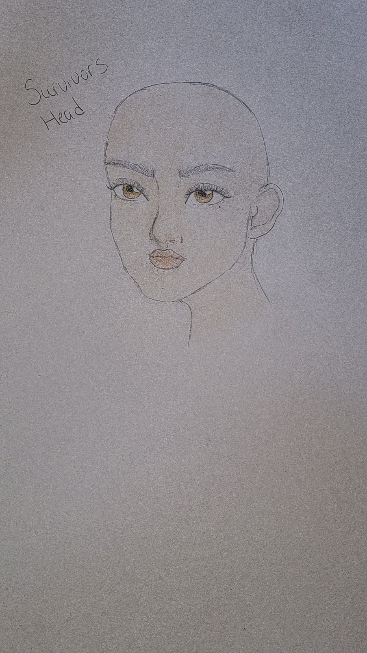
Modern Shaman –
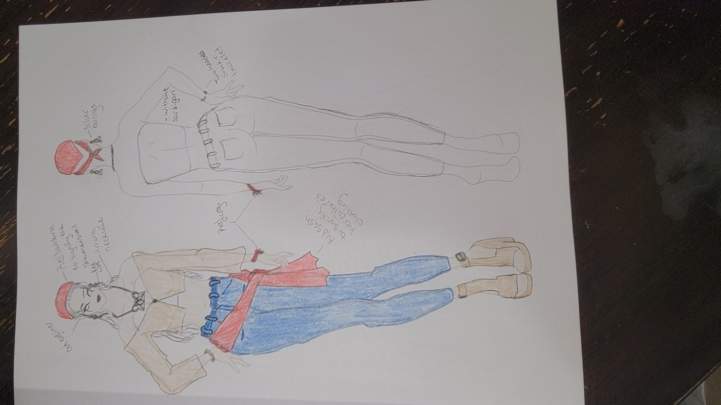
The Shaman –
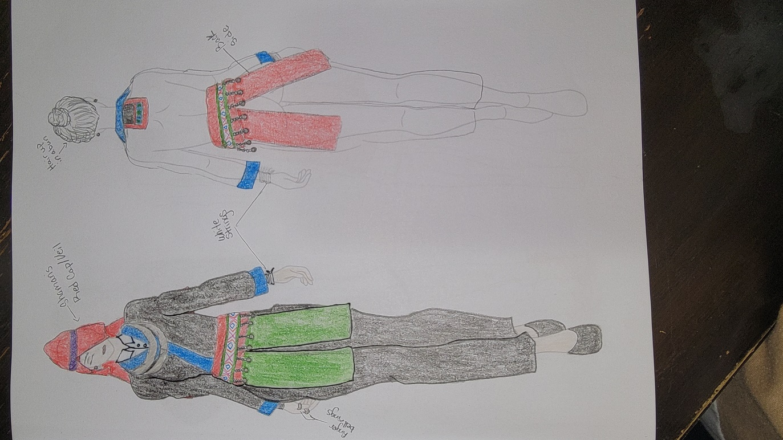
French Kiss –
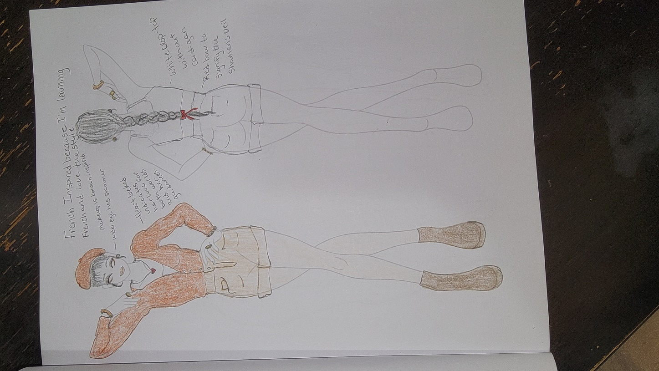
Legendary Outfits –
Nuj Nplhaib –
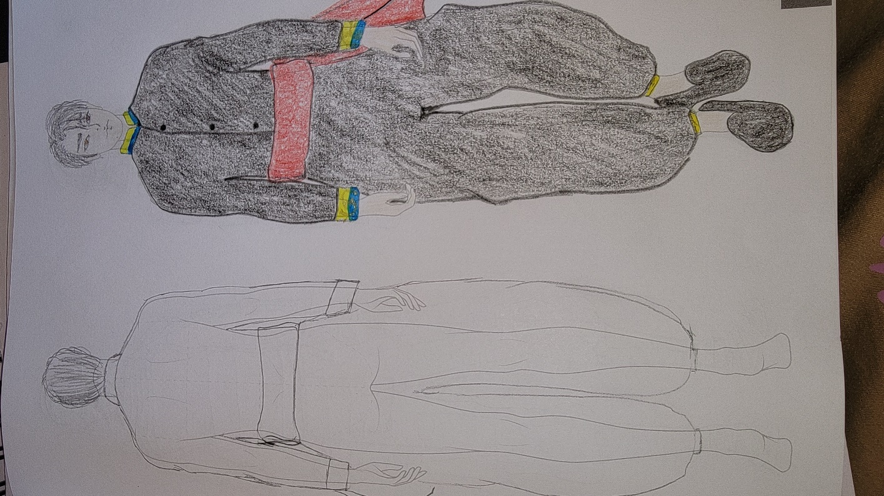
Modeled after this folklore movie’s hero
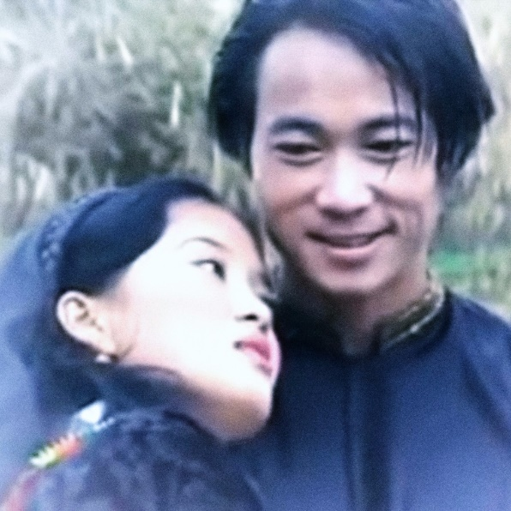
Ntxawm –
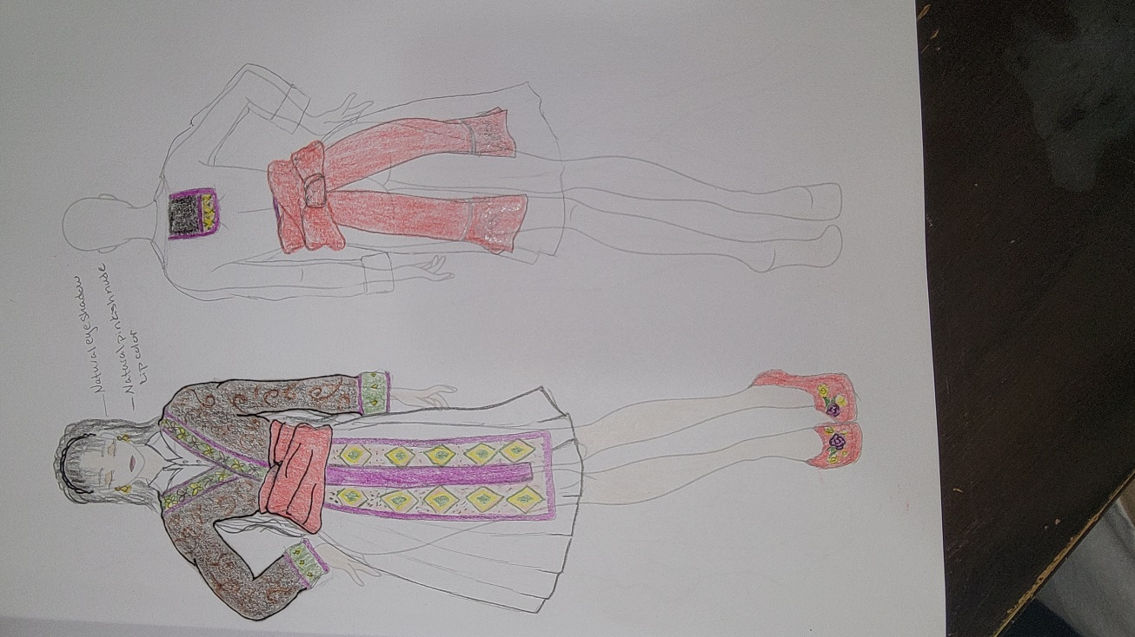
Modeled after this folklore movie’s beauty

How the hags are supposed to look like plus costume drawing design by me –
