THE ALIEN
115% Movement speed
32m Terror radius
Tall

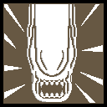
Power: Predatory Prowess
The natural capabilities developed in harsh evolutionary conditions make Xenomorphs fierce hunters.

ACTIVE ABILITY: PROWL
Holding the active ability button will switch in and out of prowling mode(0.4s in, 1s out). While in prowing mode you move at 165% movement speed, have increased vault speed, and can climb some vertical surfaces, but you accelerate slower(3.6m/s/s). While in prowling mode, you consume energy(at 2c/s) from your power(60c max) while moving and you cannot perform basic attacks or perform Vital Stab. Upon a successful basic attack, you replenish energy(18c). You also slowly passively replenish energy out of chase, and not charging Vital Stab(1c/s).

SPECIAL ATTACK: VITAL STAB
Holding the killer power button will charge Vital Stab(1.2s), slowing you to 95% movement speed. Pressing the basic attack button while Vital Stab is fully charged will Perform Vital Stab in a small cone in front of and below you. A single survivor can be hit by each Vital Stab, and they are put into the dying state. Performing Vital Stab consumes energy(20c).

MORI (choreography)
The Alien jumps on the downed survivor as they begin to roll over, pinning them. The Alien opens its mouth, and its pharyngeal jaw shoots forward through the survivor’s head.
Royal Pharyngeal Jaw variant
The Alien impales the survivor and lifts them with its tail. The POV cuts to in front of the survivor, and shortly after, the survivor's head is punctured by The Alien’s pharyngeal jaw, then the survivor falls face-first to the ground.

Perks:
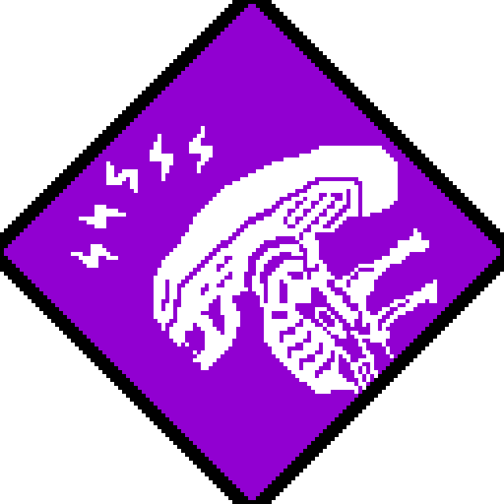
Perk 1: Extrasensory
A sixth sense resides within you subconsciously, altering you of imminent danger, or of evasive prey.
Whenever a survivor moves directly behind you at a range of 8/12/16 meters, their aura is revealed to you for 5 seconds and you both hear an auditory cue.

“The creature is known to hunt with limited light dependency. Recent theories suggest developed auditory and olfactory systems.” - Weyland-Yutani Archives 8.08:16
[I suck at making icons; would look similar to Spies From the Shadows]
Perk 2: Hive-mind
You've formed a mental link to the entity, gaining access to a sliver of its knowledge.
Survivors now have a 50%/75%/100% chance to not scare wildlife. If survivors are within 36 meters of you and within 6 meters of undisturbed wildlife, their auras are revealed to you.

“The Queen is the center of their lives, quite literally the mother of their society.” - Bishop

Perk 3: Corrosive Retaliation
Your body retaliates when you are injured.
When you are stunned by an injured survivor, they are afflicted with the deep wound status effect.
When you are stunned by a healthy survivor, the perk activates and that survivor is injured.
Corrosive retaliation has a cooldown of 160/140/120 seconds every time it activates.

"It's got a wonderful defense mechanism. You don't dare kill it." -Parker

Add-ons:
Common:
Facehugger Leg
A leg ripped from a “used” facehugger.
-Slightly(+10%) increases prowling mode movement speed
-Slightly(+0.5s) increases the time it takes to exit prowling mode
Blood Vial
A small, acid-resistant vial made specifically to hold Xenomorph blood.
-hitting a survivor with either a basic attack or a Vital Stab shortly after exiting prowling mode applies the mangled status effect
Yautja Jaw
A mandible torn from the mouth of a young Yautja that attempted to hunt a Xenomorph.
-Slightly(+20) increases Energy capacity
Exoskeleton Vertebra
A vertebra taken from a tail segment of a Xenomorph. It's unusually tough for its weight.
-Slightly(-0.2s) decreases Vital Stab charge time
Electric Prod Head
A complex electrical device used by humans to “train” Xenomorphs.
-Slightly(+1m/s/s) increases movement acceleration while in prowling mode
Uncommon:
Facehugger Tail
The still-coiled tail of a facehugger that was removed from a host mid-implantation, much to the host's dismay.
-Moderately(+15%) increases prowling mode movement speed
-Slightly(+0.5s) increases the time it takes to exit prowling mode
Egg Flap
A flap from atop an ovomorph. It still twitches whenever it detects movement.
-While in prowling mode, whenever a survivor moves directly behind you at a range of 8 meters, their aura is revealed to you and you both hear an auditory cue.
Yautja Dreadlock
A dreadlock ripped from the skull of a young Yautja who attempted to hunt a Xenomorph.
-Moderately(+30) increases Energy capacity
Dorsal Tube
A tube-like structure that grows on the back of Xenomorph drones that shed off when they molt.
-Moderately(-0.3s) decreases Vital Stab charge time
Rare:
Chestburster Arm
An arm from a recently born Xenomorph that was killed by it's host before he died.
-Considerably(+20%) increases prowling mode movement speed
-Slightly(+0.5s) increases the time it takes to exit prowling mode
Hive Resin
Sticky black sludge that coats the walls of a Xenomorph hive. It's toxic to the touch.
-hitting a survivor with either a basic attack or a Vital Stab shortly after exiting prowling mode applies the broken status effect for 90 seconds.
Yautja Claw
A finger gnawed from the hand of a young Yautja that attempted to hunt a Xenomorph.
-Considerably(+40) increases Energy capacity
Black Tail Spike
The tail tip from a fully grown Xenomorph. It's remarkably sharp.
-Considerably(-0.4s) decreases Vital Stab charge time

Very Rare:
Black Motes
Spore-like contagions that grew on the Xenomorphs’ planet of origin. Highly hallucinogenic and usually lethal to take into the body...
-Survivors that stun you become exhausted for 10 seconds.
Royal Pharyngeal Jaw
A pharyngeal Jaw ripped from a Queen Xenomorph by a Yautja warrior.
-Survivors who have been hooked twice are killed by Vital Stab.
Android Hand
The discarded hand of an android, it appears as if it had melted off.
-You damage generators, break pallets, open lockers and vault considerably(+50%) faster in prowling mode.
Ultra-Rare:
Spike’s Carcass
The hollowed corpse of an unfortunate canine.
-Tremendously(+60) increases Energy capacity
-Moderately(+20%) increases Prowl movement speed
-Disables Vital Stab
Iridescent Crest Shard
A hard exoskeleton chunk in likeness of a Xenomorph Queen's crest, moulded by the fog itself.
-Reveals the aura of survivors within 10 meters while charging Vital Stab.
-Charging Vital Stab no longer inflicts a speed penalty.
-Slightly(-20) decreases Energy capacity.
-Energy capacity does not stack, and trumps all other addons.

