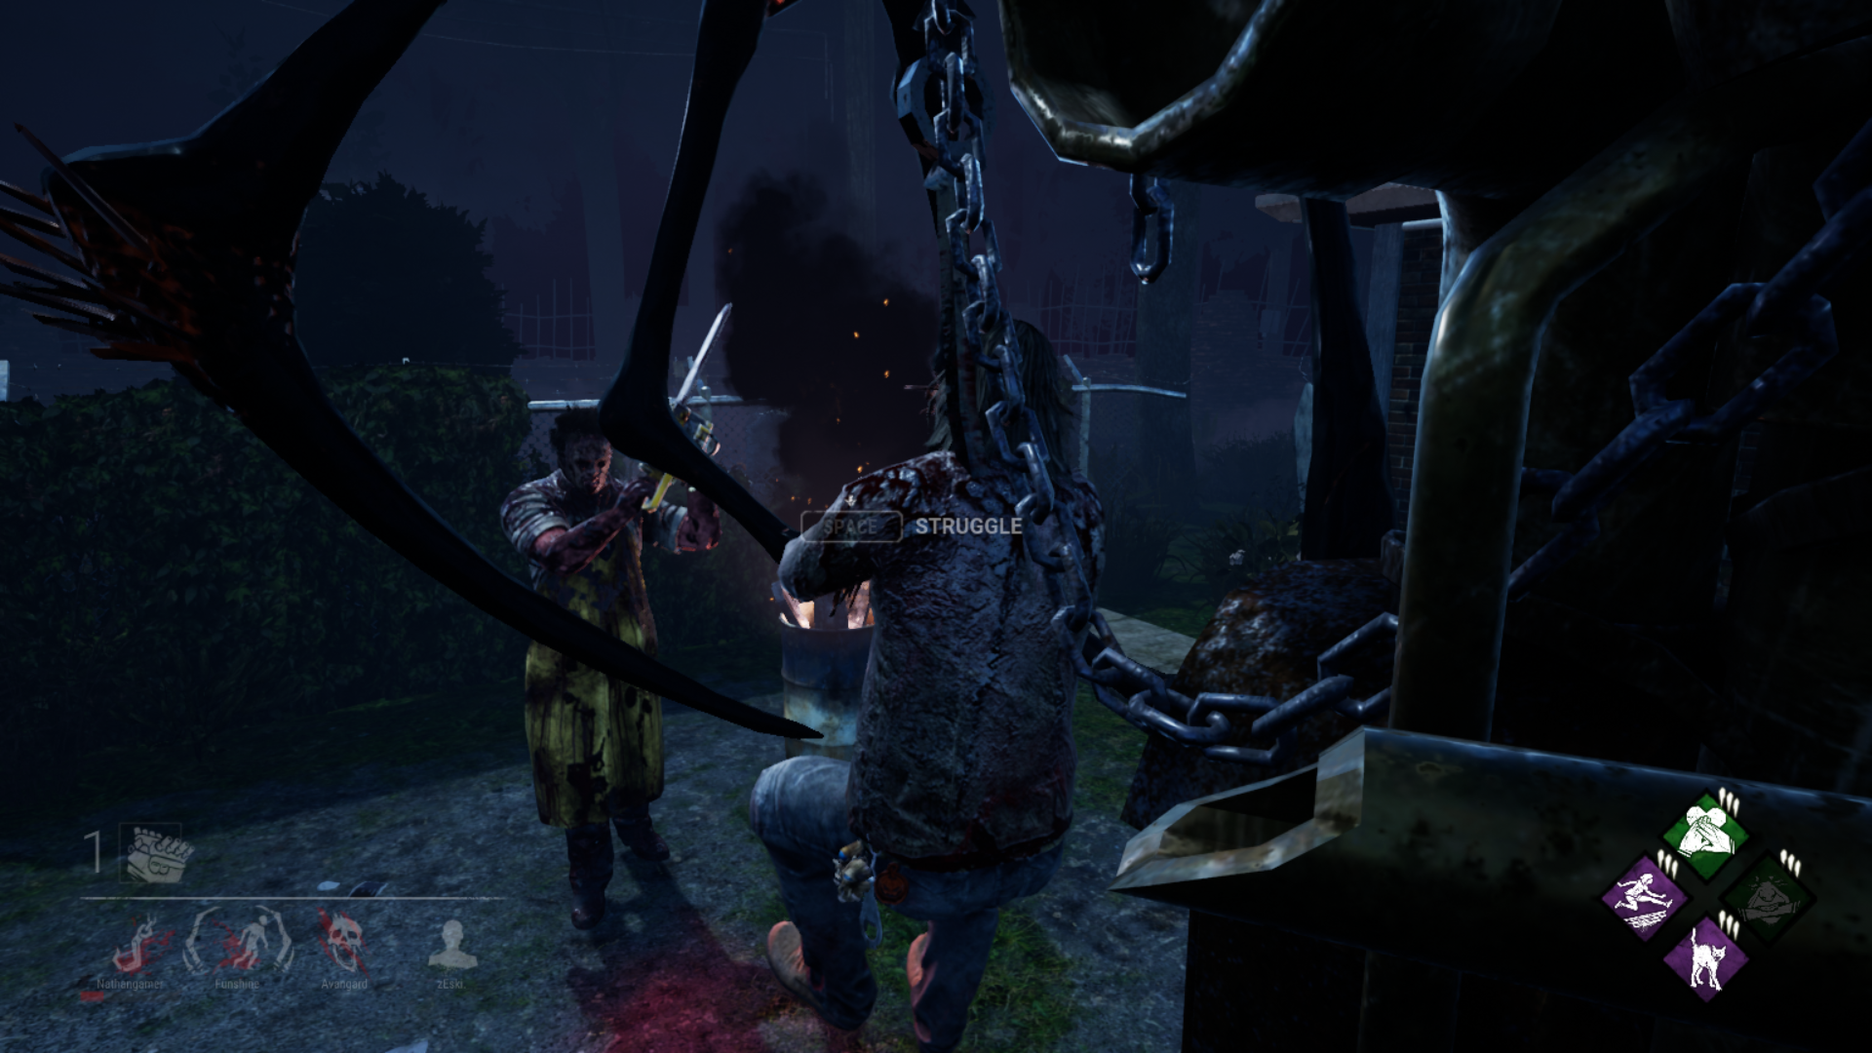

If you call this fucking valid you should all punch yourselves in the fucking face because this is not fair at all you should do something about this

If person would come and save me we both get downed again so explain too me wtf would you want me to do

