Dead By Daylight DLC ideas 2
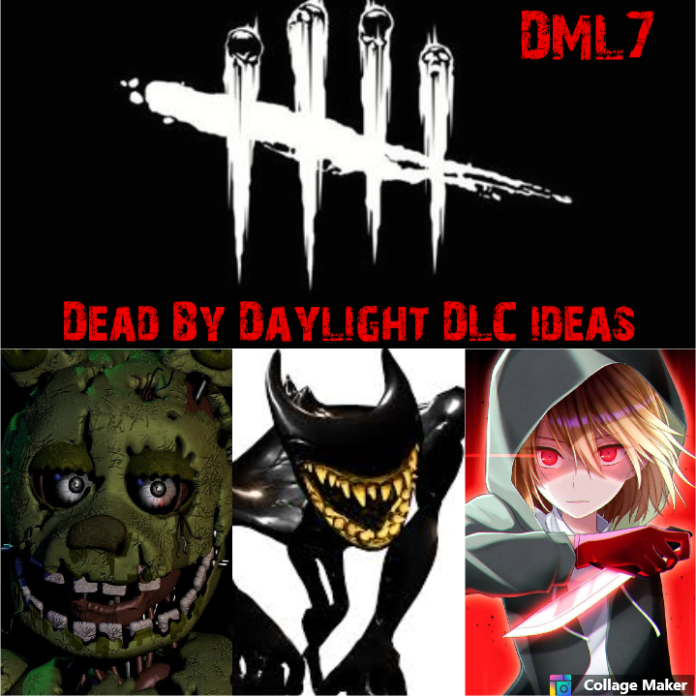

Dead by daylight X Bendy and the ink machine.

INKY BENDY (killer side)
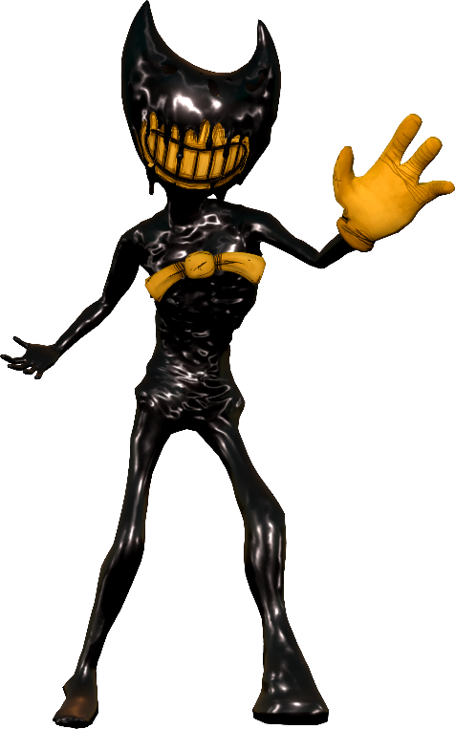

File of the killer : Ink Bendy is a failed result to recreate Bendy as a physical, living being; he has no soul, which could explain his murderous behavior, and as such, he has no proper emotions. Additionally, he never learned how to socialize due to the workers of the studio locking him up on Joey Drew's orders, preventing him from socializing with anyone or anything. With a lack of human intelligence, is also not capable of speaking words, only making noise through raspy breathing, moans, and grunts. Ink Bendy has an unnatural ability to cover areas with ink-masses and make ink rain from the ceiling whenever he appears. These ink-like masses turn out to be strong enough to kill the mutilated Butcher Gang enemies nearby showing a cold apathy toward these deformed/disfigured toons. While he can teleport in an unexpected manner by emerging from walls with ink-substances, he possesses a unique ability to optionally transform into his larger, stronger, and fearsome form, which is known as Beast Bendy.
( wikipedia files ).

Powers of the killer :

-BEAST BENDY : Once his power is fully charged, INKY BENDY can transform into his most powerfull form : BEAST BENDY. While into BEAST BENDY form, his movement speed increase but he can put the survivors down instantly. BEAST BENDY can only be active for a while and has a slow cool-down.

-INK MINIONS : INKY BENDY can leave several ink stains on the ground. Those ink stains are used as traps. If a survivor walk on an ink stain, it triggers it, releasing a member of « The butcher gang » which will attack the survivor. If the survivor is touched while in full health he becomes injured and if he is touched while already injured he get the « broken » status effect (or is put into the « dying state »). However it is possible to run away from « The butcher gang » members and they disappear after a short while.
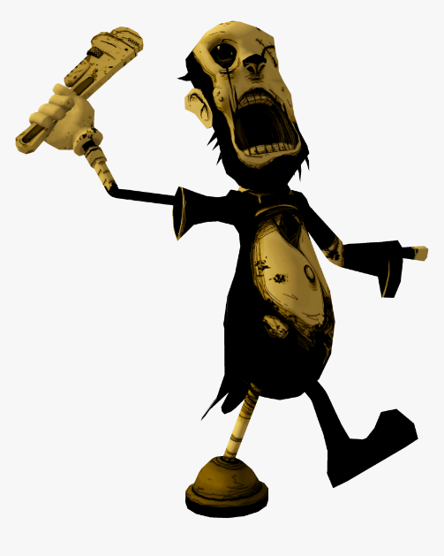
Warning : An inky minion can only attack the survivor who triggered him.

Alternate power :
-TELEPORTATION : INKY BENDY can create inky portals which he can emerge from with ink-substances.

Perks :

- Progressive rage : The idea that the survivors might get to the ending fill you with a growing powerful rage. For each fully repared generator the cool-down of your missed basic attacks is reduced by 5/10/15% and your movement speed is increased by 2,5 %.

- Worst ennemies : After getting stunned for the fourth/third/second time the last survivor who stunned you get the « exposed » status effect for 40/50/60 seconds. Worst ennemies has a cool-down of 180 seconds (or can only be used a certain amount of times).

- Carnage :
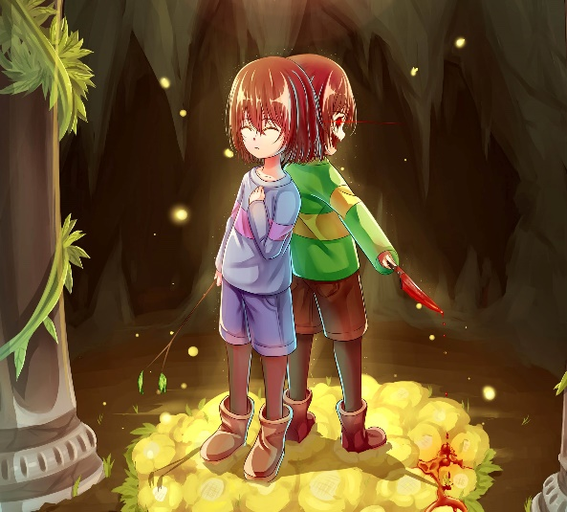
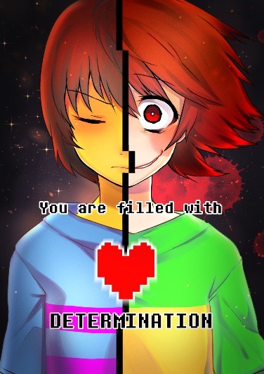
Dead by daylight X Undertale

CHARA (killer side)

File of the killer : After the Genocide road she remained lonely and trapped in the Underground. She could feel her existence slowly disappearing and her DETERMINATION decreasing. One night she woke up in a bed of flowers but she wasn’t in the Underground anymore. She was in the middle of a dark (twilight) forest. She wasn’t afraid though (however). She has never been afraid. She was now free and hungry for L.O.V.E. Her DETERMINATION rising up again, she started to grin with a devilish smile. An other Genocide had begun.

Power of the killer :
MEGALOMANIAC : Every time CHARA hits a survivor she gets DETERMINATION. This powerful energy is canalized in the blade of her knife after every hit. When MEGALOMANIAC is fully charged CHARA can throw a gust/flurry of red blades in front of her. MEGALOMANIAC will deal damage like a regular attack but is way more difficult to avoid for the survivors. MEGALOMANIAC has a maximum range which is determined by the items chose and it can touch several survivors.
Ultra rare item :
Legendary Hero : -Inflicts « Dying state » to the victim(s) touched by MEGALOMANIAC but the time/amount of hits recquired to charge MEGALOMANIAC is increased significantly.
Heart locket : - Increase significantly the maximum range of MEGALOMANIAC.


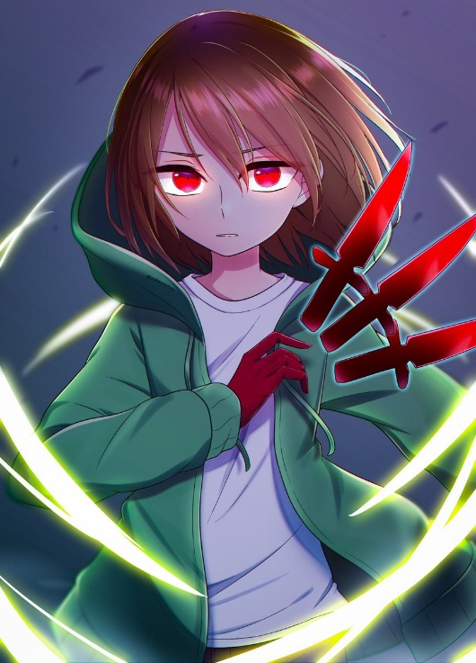
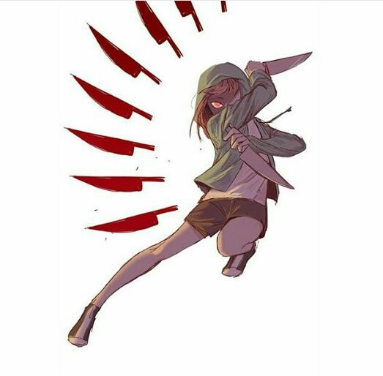
Perks :
- ERASE : You become obsessed by one survivor. For every stun caused by your obsession you get a token.
- 2 tokens : The obsession get the « exposed » status effect.
- 5 tokens : You can kill the obsession.
Warning :
-The tokens are consummed after any of those actions. -If the survivor is hooked you lose one token.
-The killer can only be obsessed by one survivor at the time. -If the obsession changes all the token are lost.

- HATE : Your frustration creates in you an endless rage. If a survivor finish a generator while he is in your Terror Radius, he get the « exposed » status effect for 20/30/40 seconds.

- L.O.V.E : The will of murdering give you strength. Every time a survivor is hooked, your movement speed is increased by 10% for 30/40/50 seconds and the cool-down of your basics missed attacks is reduced.

Other idea : when a survivor stun you with a palette a tremendously difficult Skill Check appears on every generators being worked on. If the skill check is missed the progression of the generator decrease.

FRISK (survivor side)
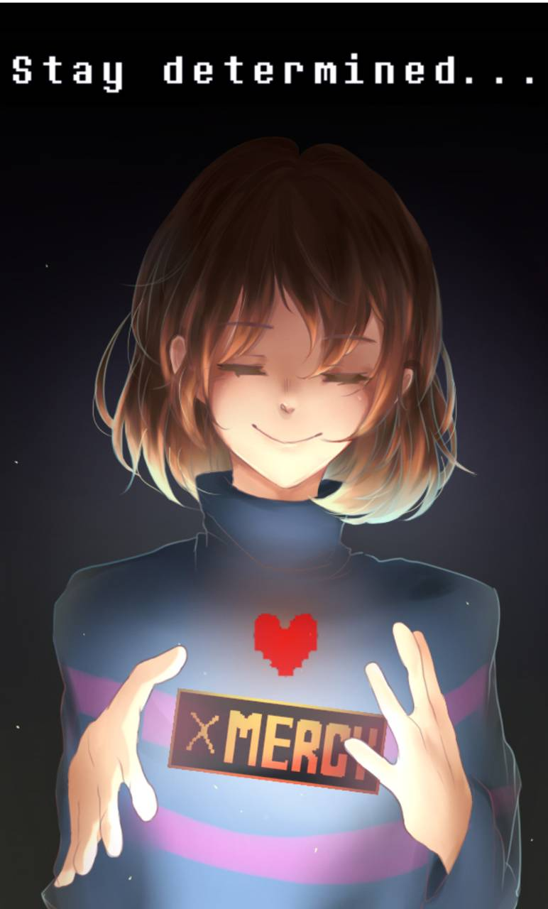

File of the survivor : For FRISK helping others has always been a normal thing. What got him into dander sometimes. But he didn’t care. Helping others was way to important and if ever anything to important happened he could always reset the timeline. However after several reset the timeline started to become corrupted and he started to have visions in which he saw a huge maleficent presence. One of his closest friend told him to be careful with that and to stop messing with the timeline but it was to late. One day or another he would have to reset. He knew the entity was waiting for it which made him paranoid. He started to have more and more visions every night. Visions where he wake up in a meadow of golden flowers but this small meadow was in the middle of a giant dark forest. One night he tried to see further in his visions to understand them. He explored the forset in which he saw a lot of generators, what he didn’t understand at first. Then he realised that the entire forest was surrounded by walls. The only exits were 2 giants exit doors out of power. It made him nervous. He wanted to go back to the reality and tried to wake up…. But nothing happened. He tried again and again…..but nothing happened.

Perks :

- DETERMINATION : the idea that this nightmare will end soon fill with DETERMINATION. For every complete generator by your teammates or yourself you gain a token up to a maximum of 3 tokens. Each token give you a 3/4/5% speed boost on heal,sabotage,unhook and reparing actions.

- SAVE : Your will of helping others is stronger than anything. Every time you unhook someone or take a protection hit while the killer is carrying someone you leave no scratch marks for 10/15/20 seconds and your speed on healing, unhooking and sabotaging is increase by 10/20/30% for 60 seconds.

- RESET : When you are unhooked for the first time RESET is active for 30/40/60 seconds. If you are put into dying state while RESET is active you get 1/2/3 extra escape attempts instead of being into struggle phase and the timer of the hook is reset. (this perk is supposed to stop killers from camping the hooks or focusing on the same survivors).

Other idea : if you still in the killer terror radius while you are on the hook the speed of the entity is reduced by 10% and the other survivors have a 5% bonus speed on healing, sabotaging, unhooking and reparing.

Dead By Daylight X Five Night At Freddy’s

Springtrap (killer side)
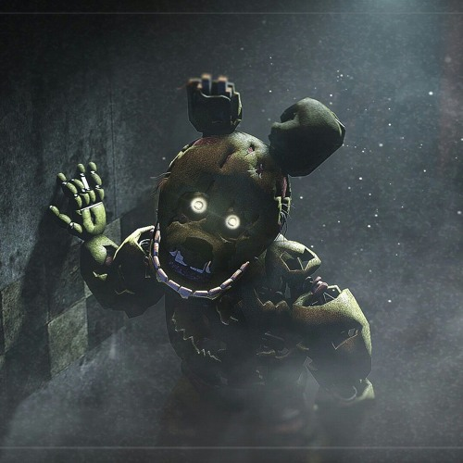
File of the killer : During his mortal life William Afton already was a monster. Called purple guy because of his uniform, he was a guard in a famous pizzeria. He seemed to be a normal employee but he was hidden a terrible secret. During his existence he kidnapped and killed a lot of kids inside this pizzeria during the night time. we never found the corpses but many years later the souls of the children came back to hunt him down. He decided to hide in a spring-lock suit that he had used to lure them in his secret room in the past. Paying no heed to the warnings we gave him on the costume, he put it on as quickly as possible. A mechanism broke and the costume suddenly tighted itself, crushing the man inside in a blood bath. 30 years later he woke up with one goal : take his revenge and wreak havoc. During a dark night, he heard a voice telling him that he would have his revenge and all the power that he wanted if he submitted to the entity. With a death glare in his eyes, he agreed. Spiders hooks coming from the shadows enveloped him and then he disappeared.

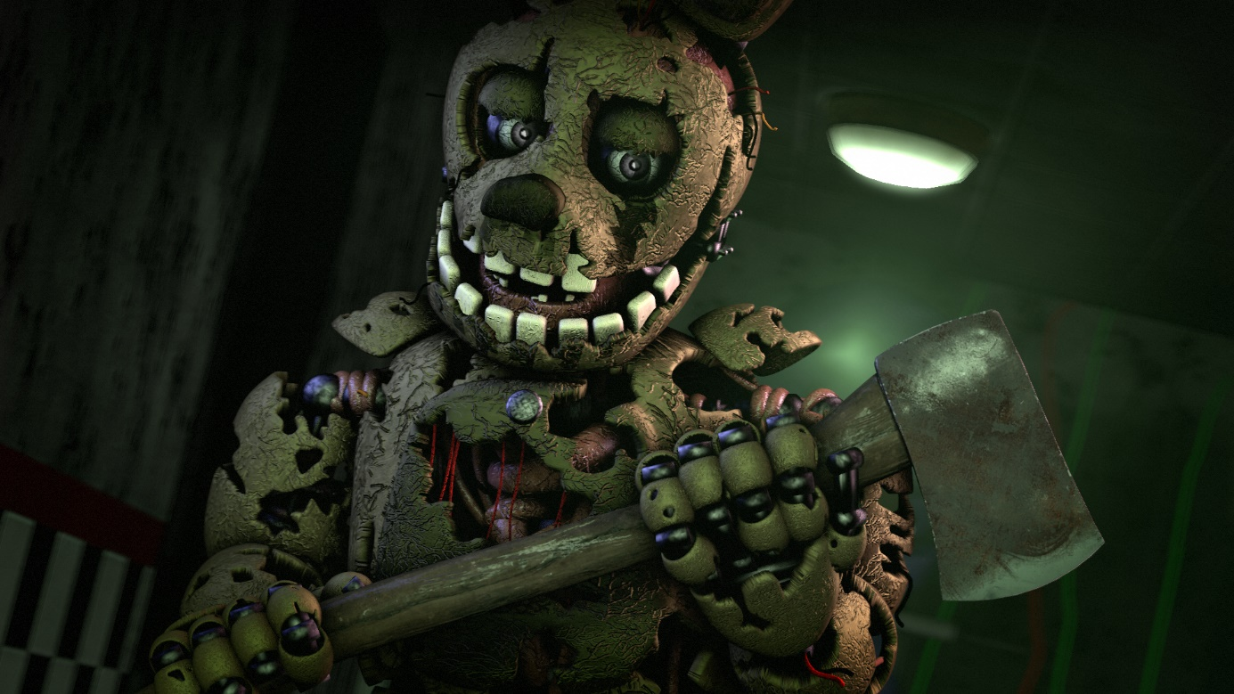
Main Weapon : Axe.

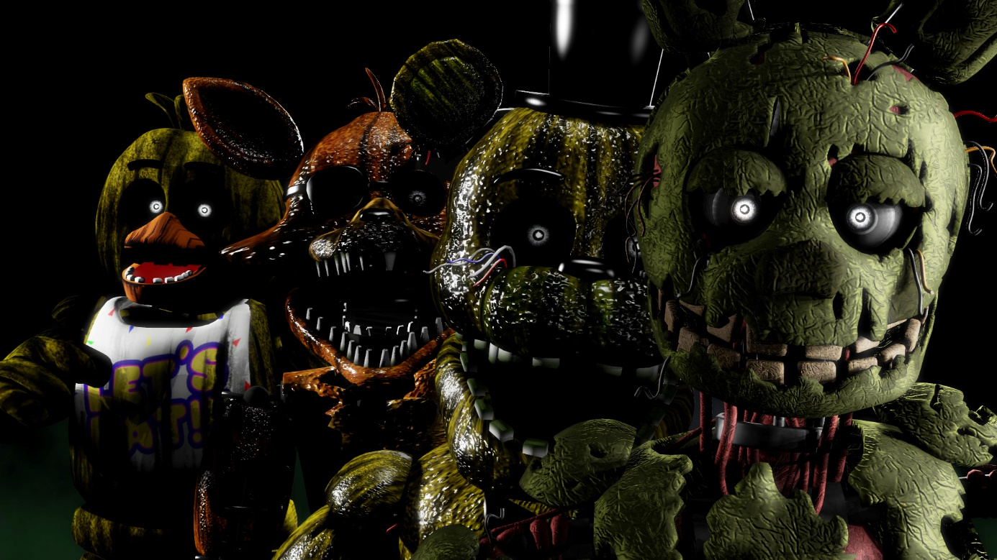
Power of the killer :
GHOST ATTACK :

