Listen before you absolutely lose it after reading the title just hear me out.
I think I should because...

Why am I so persistent?
I think the reason I’m persistent is that I’ve been burnt out on the majority of the games I own, but that's not the main reason. The main reason is that I like the suspense that it gives me and when your in the game there's always something to do if your not getting chased, whether that's finding a generator and fixing it, finding a totem and cleansing it, finding a chest and looting it, or finding the killer and giving your teammates time to do the objectives. The suspense gives me a reason to always be on my toes. If you talk about it being realistic, look underneath this paragraph. Also, I did go to you and ask if I could get it and you agreed initially, I bought it with my own money.

- THE GAME
Listen, I know that you don't care, but still, 4 individual people are faced off against otherworldly beings or humans with capabilities that succeed those of an average human. You win if you and your teammates finish 5 generators that are spread out on a map that is randomly chosen from a roster of them, open the exit gates on either side of the map and escape.

- THE GRAPHICS
Its graphics are pretty good EXCEPT when a survivor is hung on a meathook.

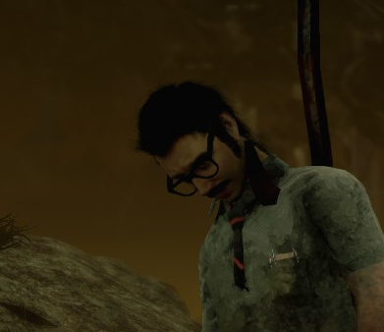
It just phases through the character model!

INTERMISSION
Guys just clarifying that this is an argumentative “essay” im not trying to be a brat about it. If you say No i’ll understand, i just want a better answer than “Cause i said so” cause that’s not much of a reason at all.

Graphics (Cont.)
Yes, it’s violent, but not as much as some horror games/movies on the market. However, there is something a Killer can equip that is used to kill survivors, called a mori. Yes its somewhat brutal, but again not as much as other games/movies.

Ex.

Dead By daylight- mori
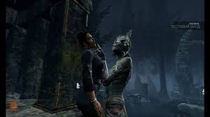
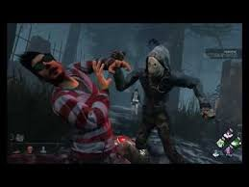
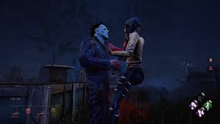

Resident Evil 2
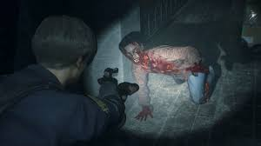

Agony
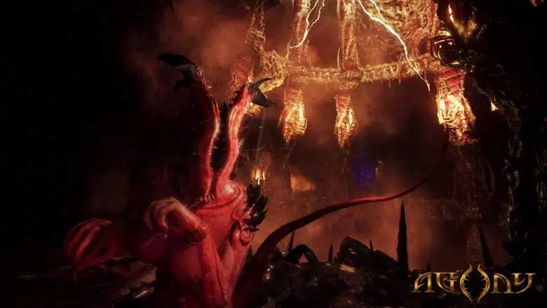
Silent Hill
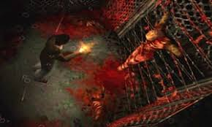

You can do more research if you want but Dead By Daylight is probably the least violent Horror game on the market.

https://www.commonsensemedia.org/game-reviews/dead-by-daylight/user-reviews/adult
Here's the review site that you use to review the majority of the games I play.

Player Actions/Behavior
Look I can’t control the actions of other players, but understand that sometimes do things that ruin the game for everyone, these people are known as trolls or hackers. Trolls will do everything in their power to make the game as unfun as possible(without hacking) They do this by tunneling (either focusing one survivor for the entire match until they are dead), now there are 2 different kinds of this. The kind trolls use and the one regular players use. Regular players will do this if you or another survivor have been running them(in a chase with them but avoids all attacks) for a long time. Another method trolls use to make the game not fun is “camping”. There are two kinds of camping: face-camping and proxy-camping. Face camping is when a survivor is hooked the killer stands right in front of them pretty much denying an escape from the hook. Survivors can sometimes bait(lure) the killer away, but this is pretty rare. Proxy-camping is when a killer stays within a 16-meter radius of you, this usually allows the Killer to bait survivors into coming to save you, however, this is not as bad as face camping. Hackers are a bane on every game on every platform and make any game not fun to play, but they can and usually do get banned. Besides those two types of players, it's a pretty positive community. If someone beats you they’re usually outplaying and win, but that teaches you on what to improve upon in the next game.

Age/Maturity
We’re almost done just hang in there.
Now I understand that you don't feel that I shouldn’t be “exposed” to this kind of stuff, but in reality, I’ve already seen worse stuff. Movies like Baby Driver and Zombieland have pretty prominent Gore/Violence and you guys only said no on your initial reaction, but then told me ok afterward. And threatening to take those things away does nothing to me. It just limits my options.
The ESRB(Entertainment Software Rating Board) does rate this game as M for mature audiences, but what does that mean? Mature Audiences? Your Body age or your Mental Age? I believe my mental age is older than my physical age. What do you think? You always tell me to form my own opinion, but you’re being hypocritical (no offense), but before I even show you a trailer, you get on CommonSenseMedia.org and see what other people think about it. Now I might be hypocritical for saying that after I posted a CommonSenseMedia.org review, but I believe that you the parent should review the game without prior knowledge or what other people think, and then come up with an opinion on your own.

CONCLUSION
Dead by Daylight is an asymmetrical horror game (Asymmetric games are those games where the players do not stand on equal ground. Different options provide different advantages and disadvantages to each player. Because a head-on attack is more advantages for one player does not mean it is as advantageous for another player.) It is violent and somewhat gory I’m not going to sugarcoat it. I am not being asked to do this by my friends, surprisingly I really do enjoy the game as a whole, playing with my friends is just a bonus. I like this game a lot and I hope you agree to let me get it.

